**MEP25**

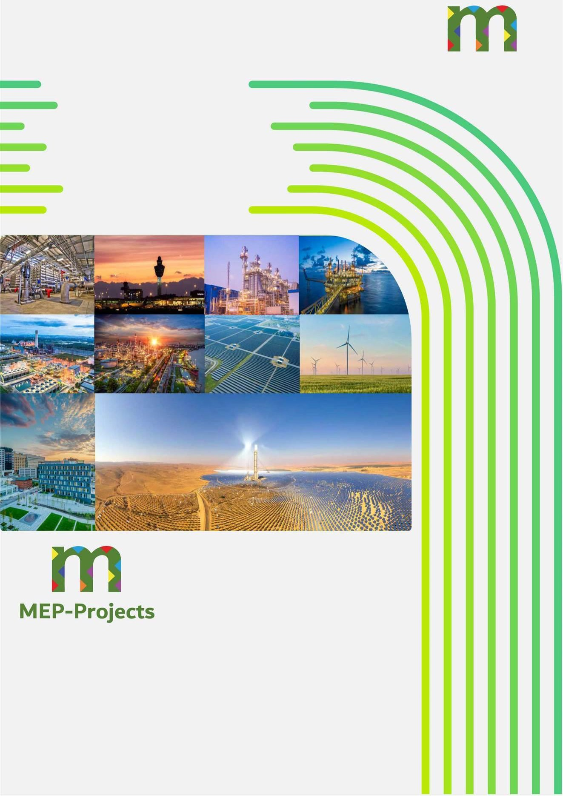

MEP25XXX

Technical-Economic Offer for Water Projects

Contents

1. INTRODUCTION 4

Background 4

Purpose 4

Contacts 4

1. SIMILAR REFERENCE PROJECTS 4

General 4

Reference Projects 5

 Desalination Plant Djibouti 6

 Salalah Desalination Plant 9

 Taweelah Desalination Plant 13

 Southern R01 Desalination Plant 15

 STP4 Wastewater Treatment Plant 16

 Barka V Desalination Plant 17

 Jubail 3A Desalination Plant 22

 Agadir Desalination and Irrigation Project 24

 Dubal Desalination Plant 30

Shuaibah III Desalination Plant 33

Sewerage Network and Pumping Station in Dubai 35

# INTRODUCTION

## Background

MEP-Projects has prepared this document for the company , and it is addressed to

on behalf of the company, to present our experience in water projects that we have carried out.

## Purpose

The purpose of this offer is to define the scope and price.

## Contact

If you have any questions regarding this proposal or any other related matter, please do not hesitate to contact the following persons:

|  |  |  |
| --- | --- | --- |
| **Contact details** | | |
| **Name** | **Position** | **Contact** |
| Andrea Vaquero Ramírez | Business Development Representative | +34 744 780 779 |
| Francisco Martín de Juan | Business Development Manager | +34 744 745 758 |
| Fran Gallego | Chief Technology Officer | +34 666 292 578 |

# SIMILAR REFERENCE PROJECTS

## General

MEP-Projects has the necessary capabilities to guarantee an excellent proposal and development for this project. We have extensive experience in the management and development of basic, detailed and tender engineering projects.

MEP-Projects is a leader in water projects. The company's activities are carried out from our headquarters located in Seville (Spain), within the European Community, from where all projects, both national and international, are carried out.

At our company, we always strive to stay at the forefront of the latest trends and technological developments to ensure that our work is efficient, innovative and aligned with best practices in the sector. This culture of constant learning allows us to take full advantage of the most advanced software tools and platforms, ensuring that we can offer high-quality products and services to our clients and remain competitive in a dynamic and constantly evolving business environment. Our dedication to proactively exploring and adopting new technologies reflects our commitment to excellence and continuous improvement.

Furthermore, at MEP-Projects we are committed to offering comprehensive solutions at all stages of a project. From the initial feasibility assessment and design phase (IFD), through the procurement

phase (IFP), to the construction phase (IFC), we work closely with our clients to ensure a comprehensive and efficient approach at all stages of the project lifecycle. Our experience ranges from initial conceptualisation and planning to successful execution and delivery, providing services tailored to the specific needs of each phase of the project.

MEP-Projects works in the field of desalination in the disciplines of Civil, Mechanical and Piping, Processes, Electrical, Instrumentation and Control, and Auxiliary Installations.

## Reference Projects

In recent years, we have developed projects related to different disciplines in the water sector, covering the following disciplines: development, electrical engineering, instrumentation and control engineering, civil engineering, mechanical and piping engineering, auxiliary installations and services.

Focusing on the desalination sector, our company has carried out numerous desalination projects of different capacities, including the complete development of the detailed engineering of the different disciplines mentioned above.

Below is a summary table of the different projects carried out in the water sector, most of which are desalination projects.

|  |  |  |  |  |
| --- | --- | --- | --- | --- |
| **It.** | **Project Title** | **Capacity** | **Location** | **Year** |
| **1** | Dubai Strategic Sewerage Tunnels | 5.33 m3/sec | United Arab Emirates | 2025 |
| **2** | Detailed engineering Rabigh 4 desalination  plant |  | Saudi Arabia | 2024 |
| **3** | Jubail-Burajdah Water Transmission System (WTS) |  | Saudi Arabia | 2024 |
| **4** | Protugal Desalination Plant | 64 MLDS | Portugal | 2024 |
| **5** | Cordoba Wastewater Treatment Plant  24055 |  | Córdoba (Spain) | 2024 |
| **6** | Improvement of Vranishta WWTP 24051 |  | Vranishta (North Macedonia) | 2024 |
| **7** | Al Jaroudia Pumping Station | 3 * 50,000 m³ | Saudi Arabia | 2023 |
| **8** | Safwa Pumping Station | 1 * 22,000 m3 | Saudi Arabia | 2023 |
| **9** | Saihat Pumping Station | 2*25,000 m3 | Saudi Arabia | 2023 |
| **10** | Albendín WWTP Project |  |  | 2023 |
| **11** | KSA Pumping Station |  | Saudi Arabia | 2023 |
| **12** | KSA Oxagon WRRP | 17,800 m3/d (liquids) | Saudi Arabia | 2023 |
| 3,035 m3/d (solids) |
| **13** | Engineering Offer Desalination plants 60  and 40 MIGD |  | UAE | 2023 |
| **14** | Barka V Desalination Plant | 110,000 m3/d | Oman | 2022 |
| **15** | STP4 Wastewater Treatment Plant | 90,000 m3/d | Saudi Arabia | 2021 |
| **16** | Southern RO1 Desalination Plant | 30,000 m3/d | Saudi Arabia | 2021 |

|  |  |  |  |  |
| --- | --- | --- | --- | --- |
| **17** | Jubail 3B Desalination Plant | 400,000 m3/d | Saudi Arabia | 2020 |
| **18** | Jubail 3A Desalination Plant | 600,000 m3/d | Saudi Arabia | 2020 |
| **19** | Taweelah Desalination Plant | 909,000 m3/d | United Arab Emirates | 2020 |
| **20** | Dubal Desalination Plant | 47,750 m3/d | United Arab Emirates | 2020 |
| **21** | Agadir-Chtouka Irrigation Project | 15,000 ha | Morocco | 2020 |
| **22** | Agadir-Chtouka Desalination Plant | 275,000 m3/d | Morocco | 2019 |
| **23** | Salalah Desalination Plant | 114,000 m3/d | Oman | 2019 |
| **24** | El Carambolo Drinking Water Treatment Plant |  | Spain | 2018 |
| **25** | "Sousse" Desalination Plant | 50,000 m3/d | Tunisia | 2018 |
| **26** | Shuaibah III Desalination Plant | 250,000 m3/d | Saudi Arabia | 2018 |
| **27** | Djibouti Desalination Plant | 45,000 m3/d | Republic of Djibouti | 2018 |

Some of the projects mentioned are described below.

## Desalination Plant Djibouti

Djibouti is a 45,000 m3/day desalination plant located in Doraleh (Djibouti). The project consisted of developing all the detailed engineering for the electrical and process disciplines, as well as carrying out the 3D work. This plant is a reverse osmosis desalination plant with an initial capacity of 22,500 m³/day, with civil engineering infrastructure designed for future expansion to 45,000 m³/day. It also included the construction of a 5,000 m³ regulating reservoir and an 8.5 km pipeline with a diameter of 700 mm, connecting the plant to the city's drinking water distribution network.

Below are some images of the detailed engineering work carried out for this project:

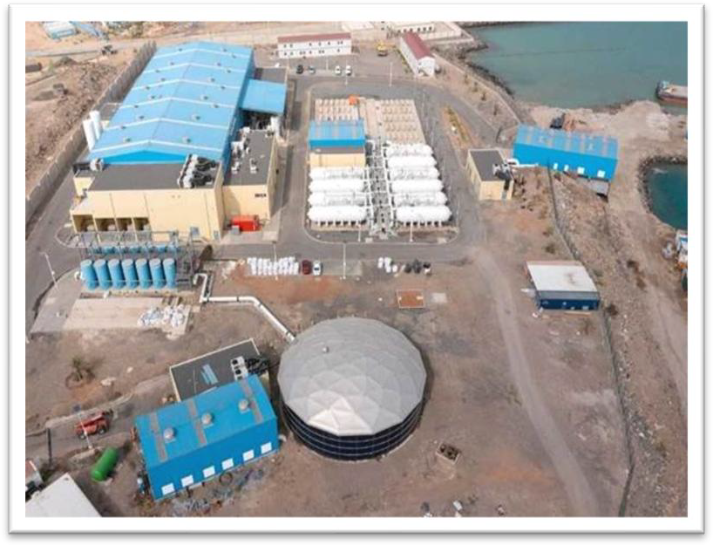

*Image1 .-Actual image of the general layout of the plant*

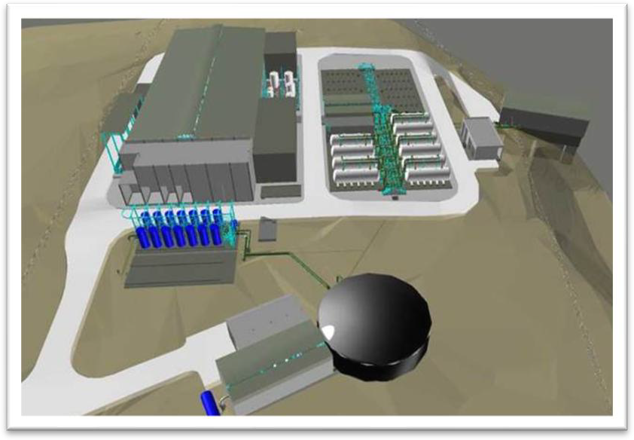

*Image2 : View of the 3D model of the plant*

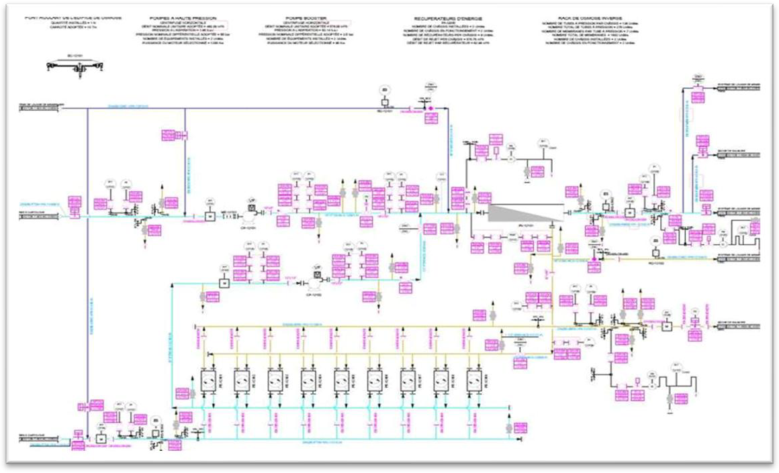

*Image3 .- P&amp;ID of the plant*

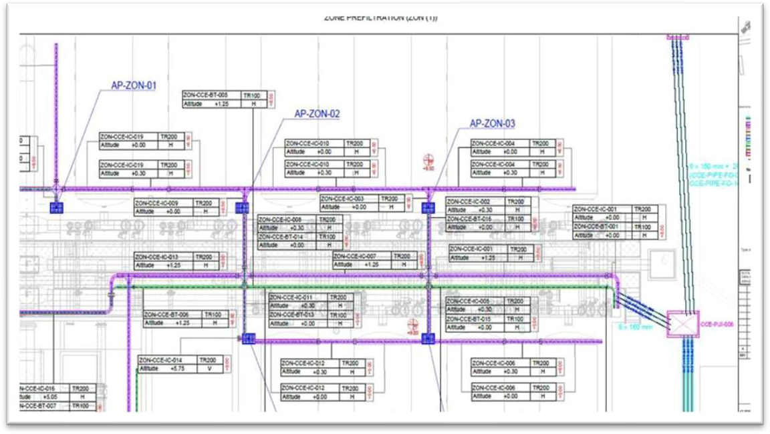

*Image4 : Electrical tray layout*

## Salalah Desalination Plant

Salalah is a 114,000 m³/day desalination plant located in Oman. The design of this desalination plant includes a seawater pretreatment line, consisting of a Dissolved Air Flotation (DAF) system plus a two- stage multimedia filtration system with gravity and pressure filters.

MEP-Projects participated in the detailed engineering of the Electrical and Instrumentation and Control disciplines, playing a very active role in the procurement and construction engineering of the Instrumentation and Control discipline.

Below are some images of the detailed engineering carried out for this project:

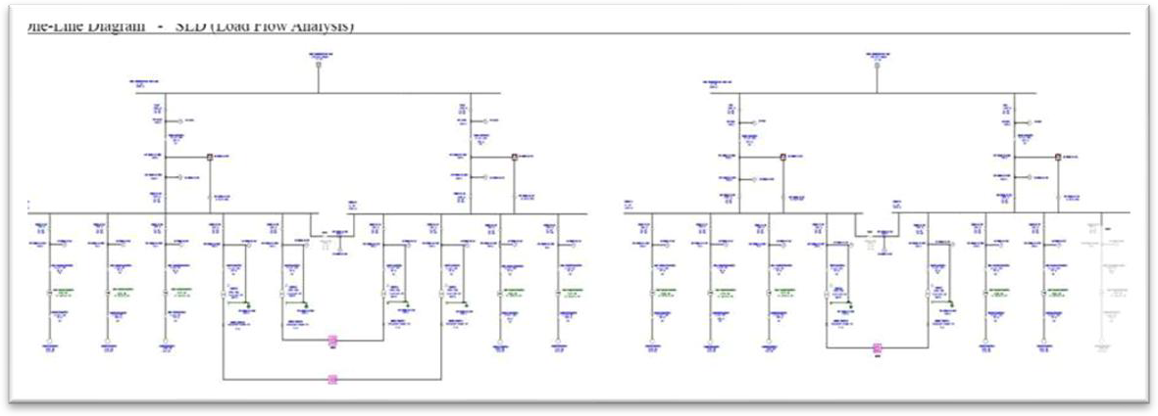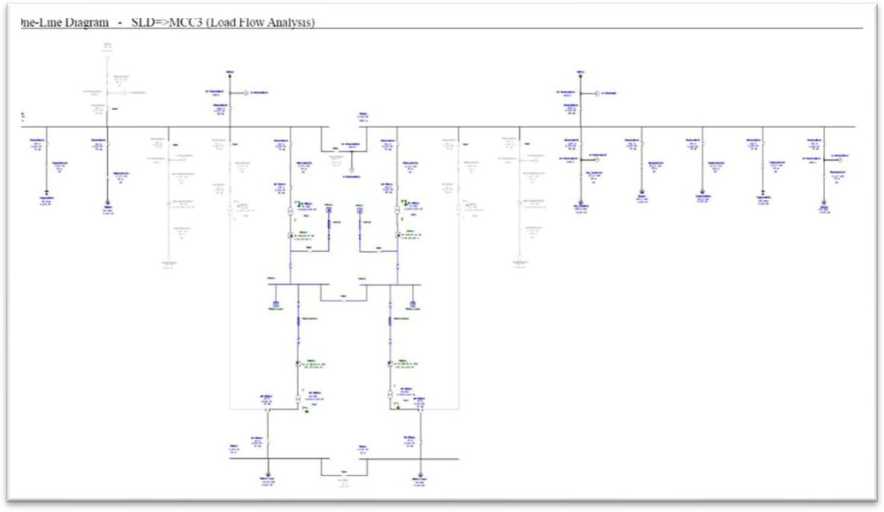

*Image5 .- Details of the single-line diagrams modelled for the studies carried out at the ETAP*

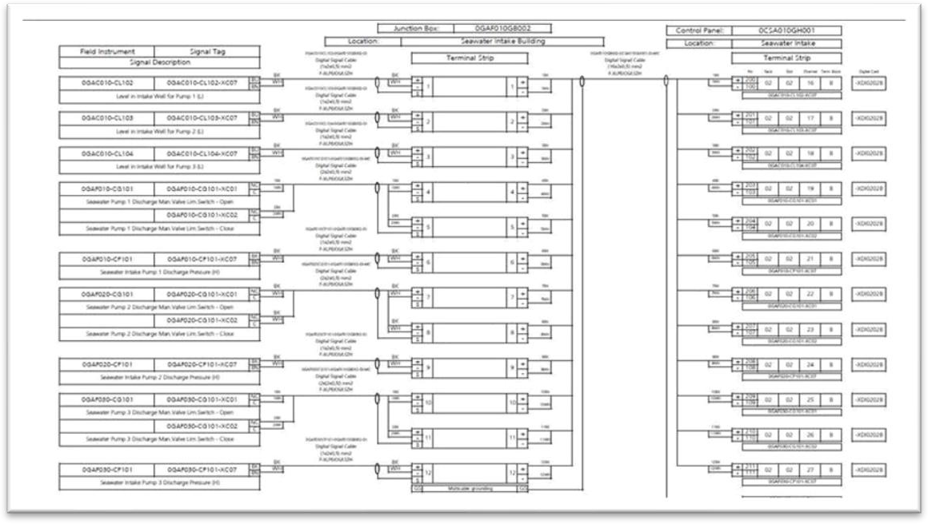

*Image6 .- Detail of the interconnection diagram*

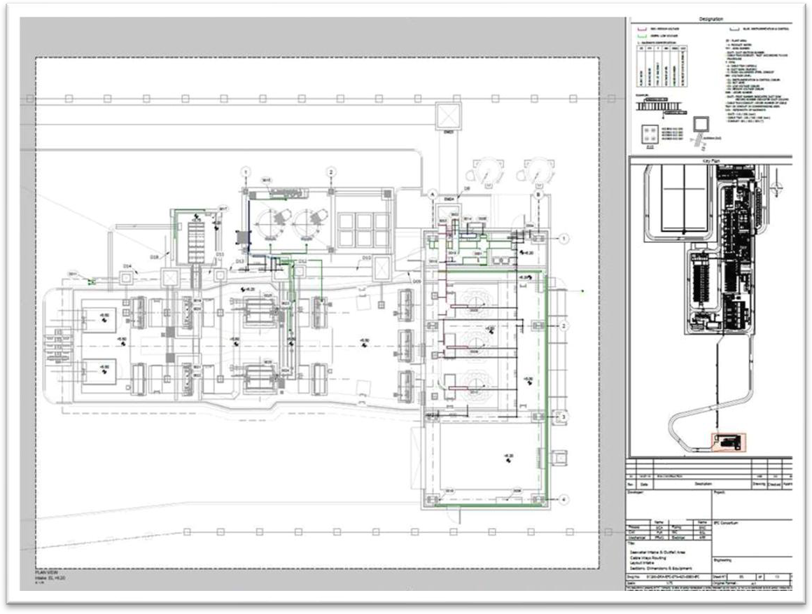

*Image7 .- Plan of trays in the seawater collection system.*

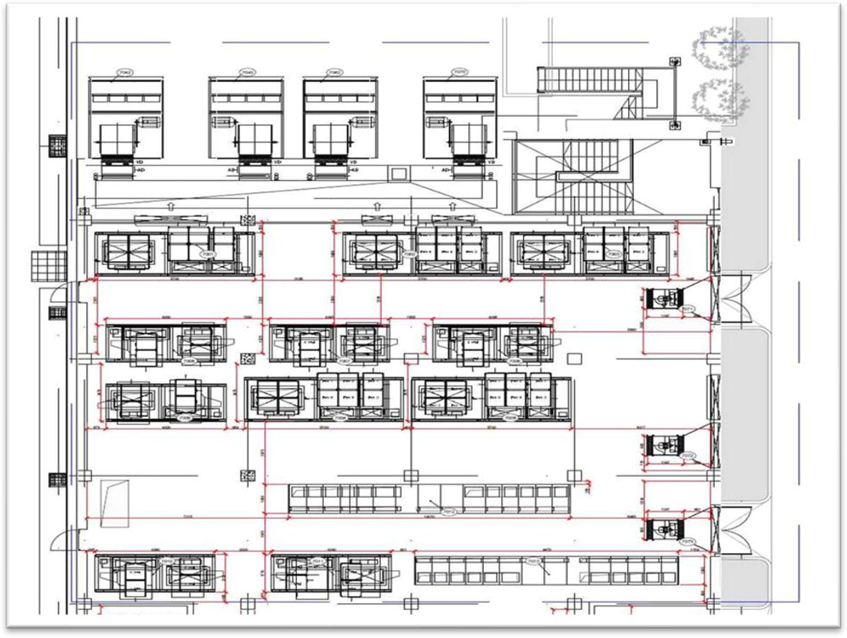

*Image8 .- Dimensioning of equipment in the electrical room*

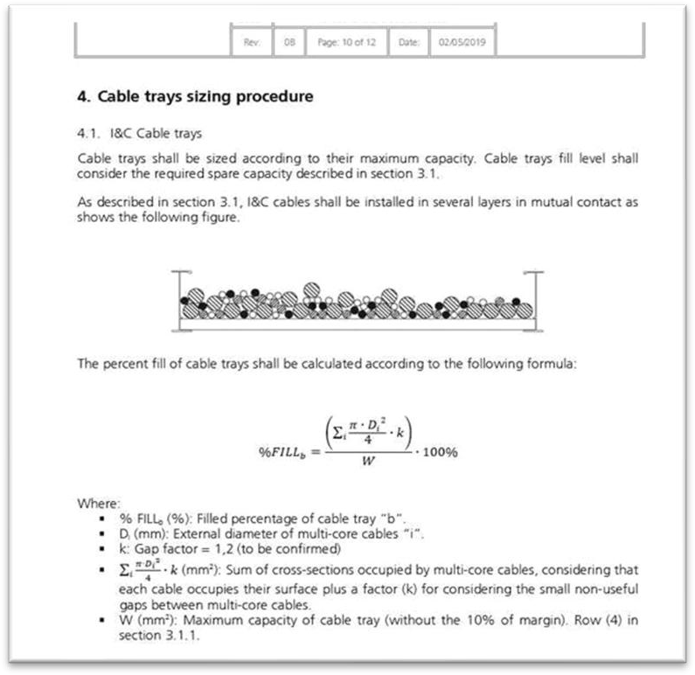

*Image9 .- Detail of the document Calculation of trays and conduits*

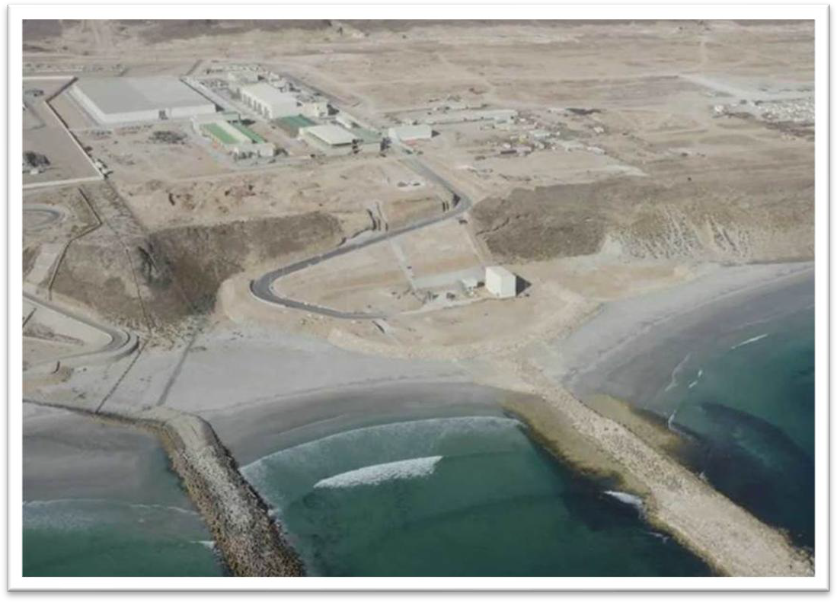

*Image10 . - Image of the plant in operation*

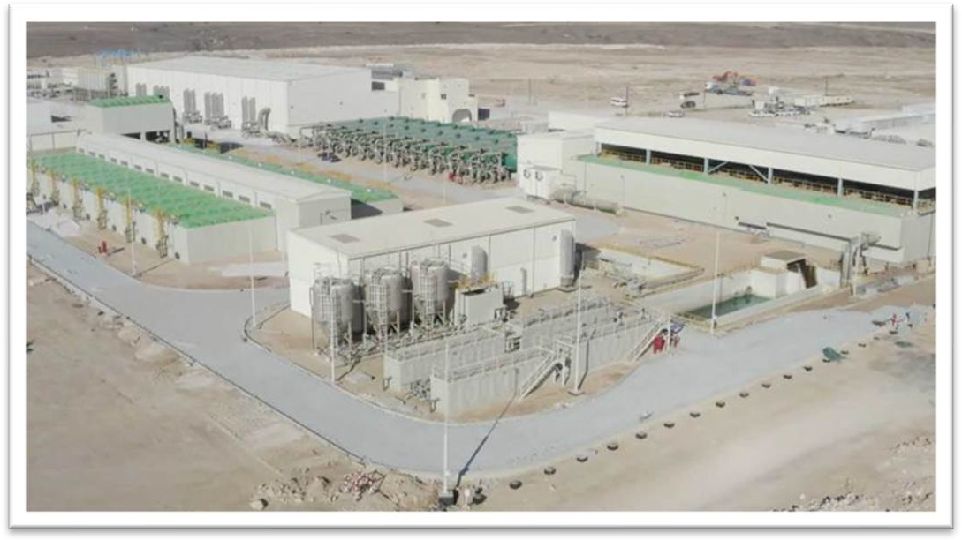

*Image11 .- Image of the plant in operation*

## Desalination Plant

MEP-Projects carried out the detailed engineering for what is currently the largest desalination plant in the world, within the discipline of Instrumentation and Control, and participated in a large part of the 3D modelling of the plant.

With a capacity of 909,000 m³/day, the plant mainly consists of a seawater intake, a reverse osmosis section for the production of permeate water, a special pipeline for the return of a concentrated brine stream, and remineralisation treatment to obtain drinking water. Due to the plant's large production capacity, the reverse osmosis system has two lines of reverse osmosis frames, each with 18 first-stage frames and 18 second-stage frames, for a total of 36 frames per line and 72 frames in total.

Below are images of the detailed engineering development of this project:

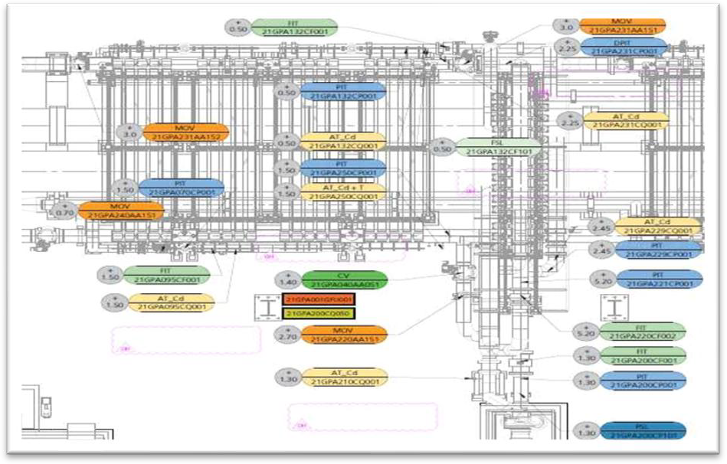

*Image12 : Detail of the Instrumentation Plan, in the Reverse Osmosis Racks area*

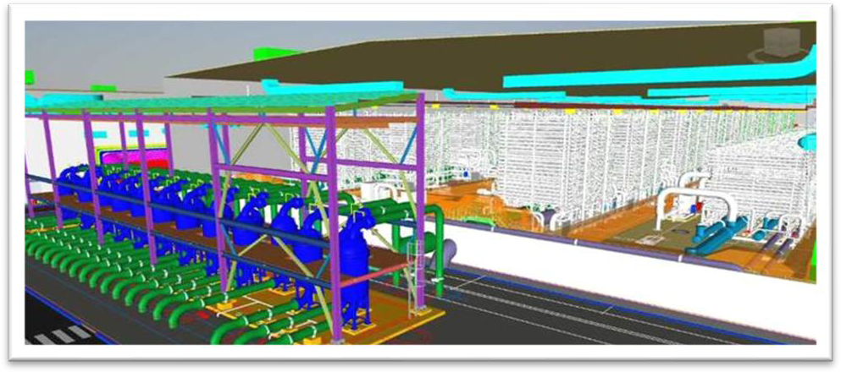

*Image13 .- 3D view of the reverse osmosis racks and cartridge filters*

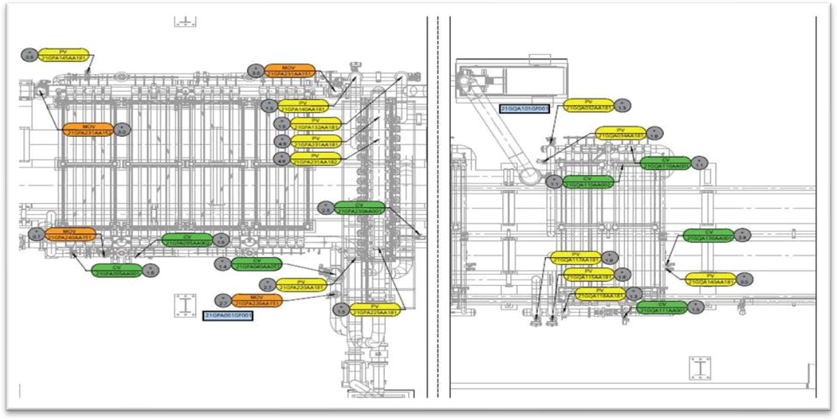

*Image14 .- Detail of the valve layout, in the reverse osmosis frame area*

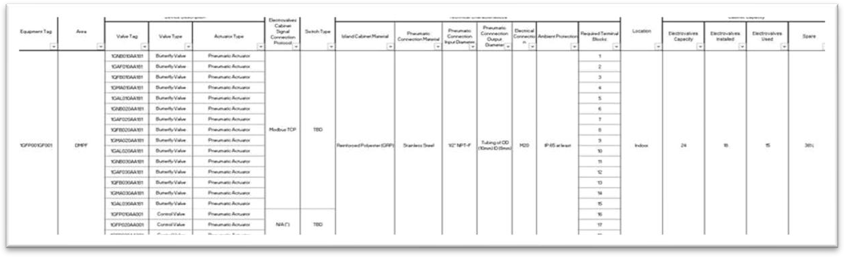

*Image15 .- Detail of the document List of solenoid valve boxes*

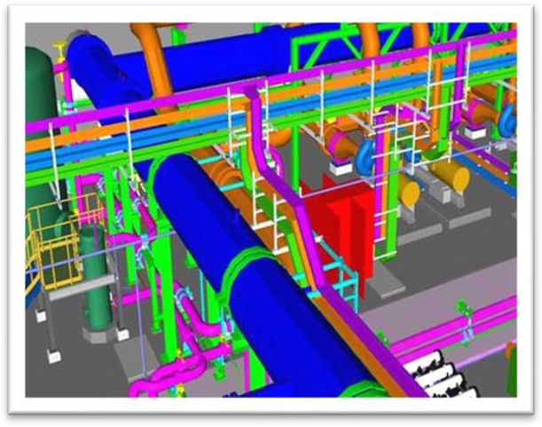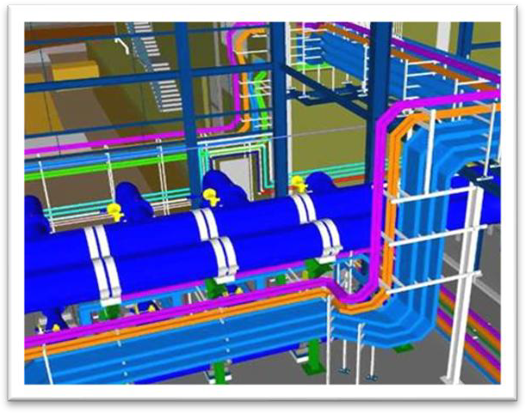

*Image16 .- Electrical supports and trays. 3D model*

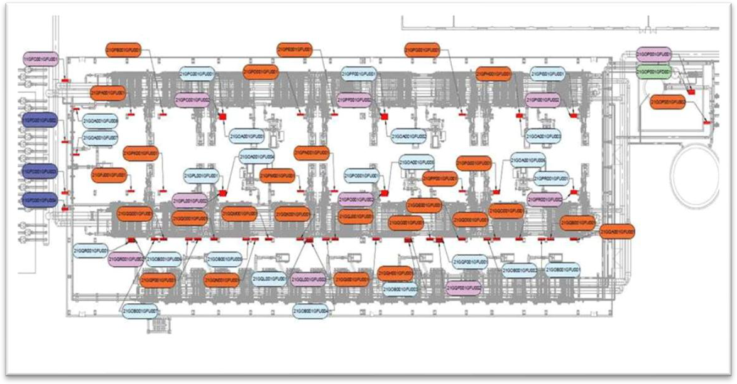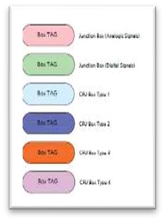

*Image17 .- Layout of the location of the instrumentation connection boxes*

## Southern R01 Desalination Plant

Southern RO1 is a 30,000 m³/day desalination plant located in Saudi Arabia. MEP-Projects carried out the detailed engineering and technical procurement management for the instrumentation and control discipline.

The project includes seawater intake, pumping, pre-treatment, reverse osmosis system with energy recovery, post-treatment, pumping station, product water storage, effluent treatment and discharge to the outfall.

Below is a representative image of the project:

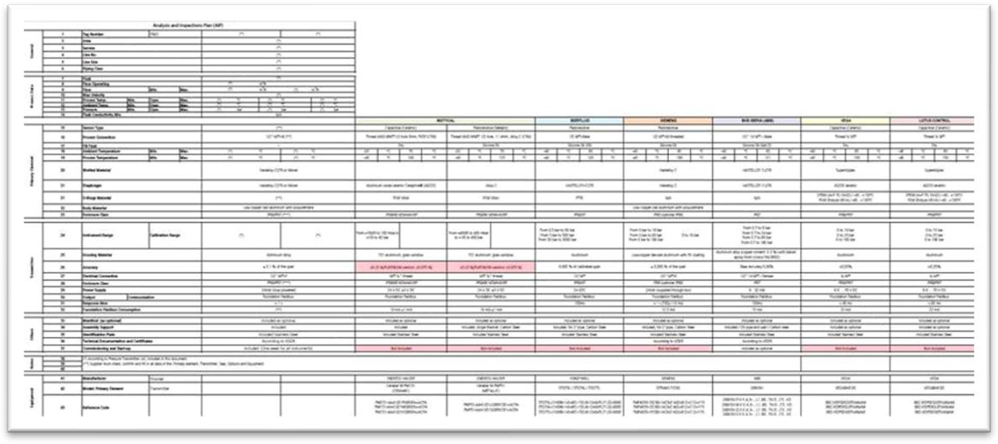

*Image18 .- Detail of a technical comparison*

## STP4 Wastewater Treatment Plant

MEP-Projects participated in the detailed engineering of a wastewater treatment plant, with the discipline of Instrumentation and Control.

This plant has a wastewater treatment capacity of 16,000 m³/day. The technology selected for the treatment of this water is Artificial Wetlands. This treatment system is based on circulating the wastewater through artificial wetlands, where physical, chemical and biological processes take place that reduce the pollutants present in the water. The plant consists of three types of facilities: primary treatment, secondary treatment and tertiary treatment.

Primary treatment consists, first, of coarse and fine screening, followed by a sand and grease removal system. Secondary treatment includes homogenisation and equalisation tanks, designed to ensure that the flow to the wetlands is consistent and homogeneous. Secondary treatment also includes artificial wetlands, which are the main component of wastewater treatment. Finally, tertiary treatment consists of a chlorine disinfection process in a water storage tank, the main objective of which is to disinfect the water for subsequent distribution and discharge.

Below are some images of the works carried out in this project:

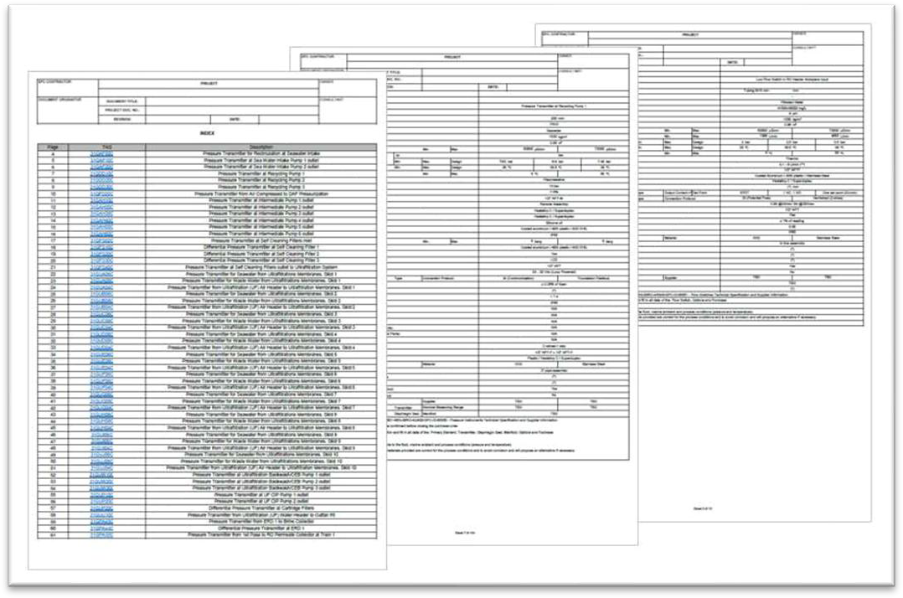

*Image19 .- Detail of the technical specifications of the instruments*

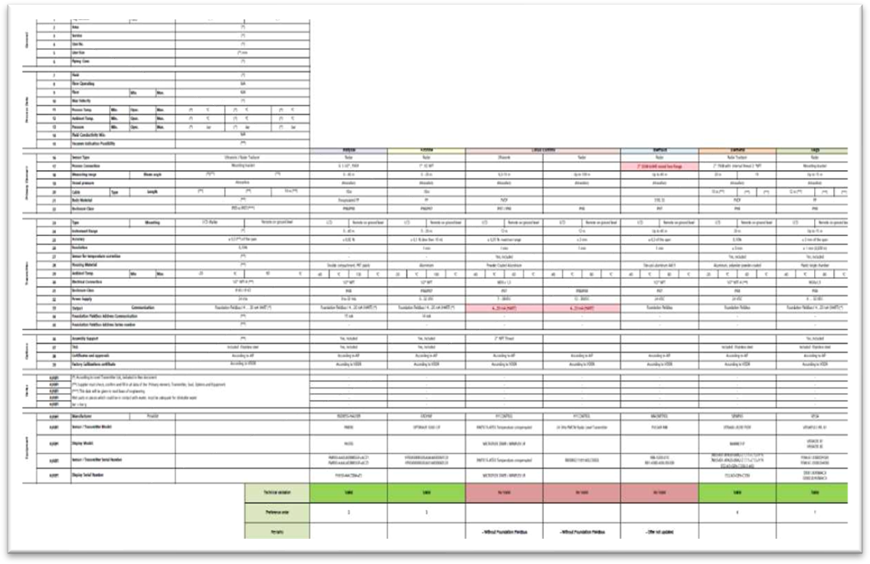

*Image20 .- Detail of a technical comparison*

## "Barka V" Desalination Plant

MEP-Projects has carried out the detailed engineering for this desalination plant with a production capacity of 100,000 m³/day. This plant is located in Barka, north of Muscat, Oman, and will complete the desalination complex that currently supplies residents in the surrounding area.

MEP-Projects also participated in this project in the disciplines of Process, Mechanical and Hydraulics, Piping, Civil, Electrical and I&amp;C.

Below are some images of the detailed engineering development of this project:

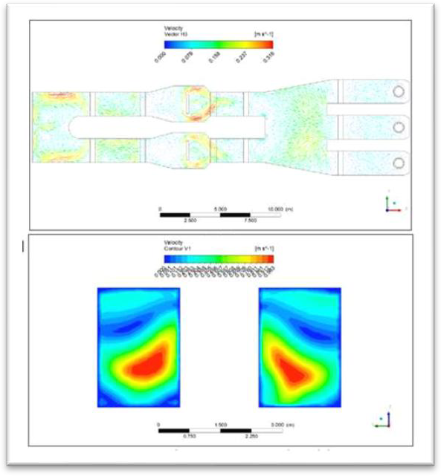

*Image21 .- Velocity profile inside the seawater intake tank*

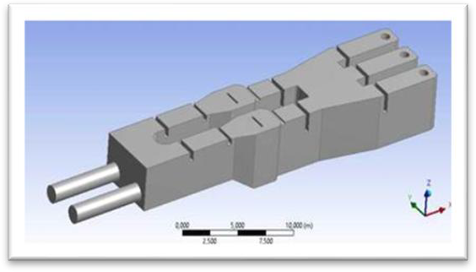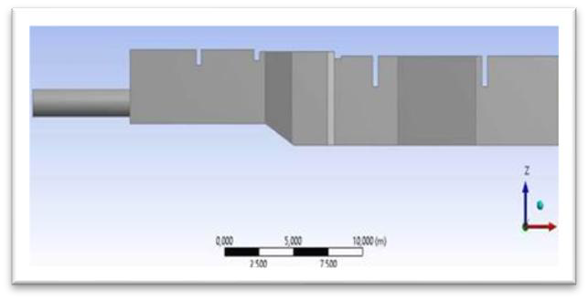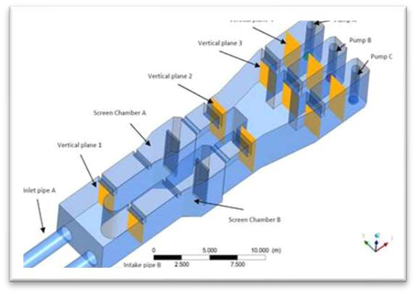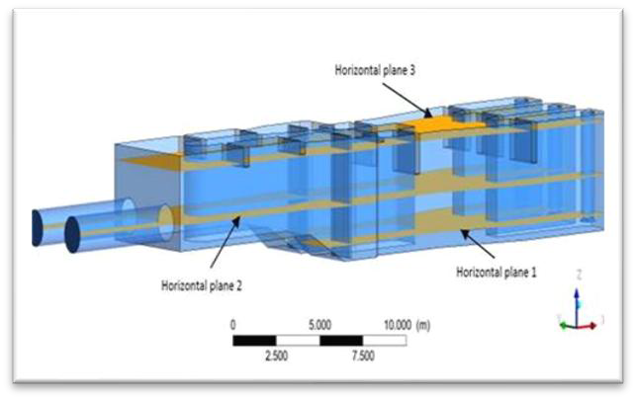

*Image22 .- Detail of computational fluid dynamics (CFD)*

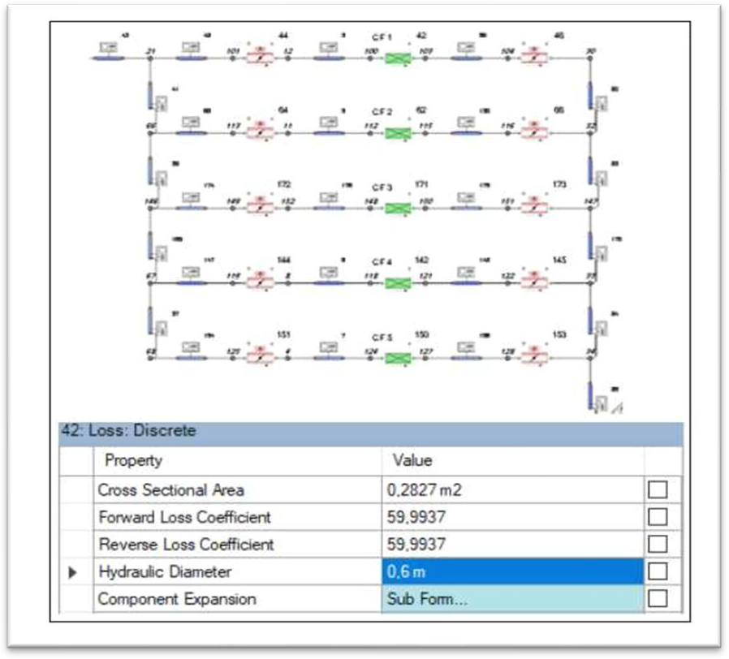

*Image23 .- Hydraulic modelling of reverse osmosis*

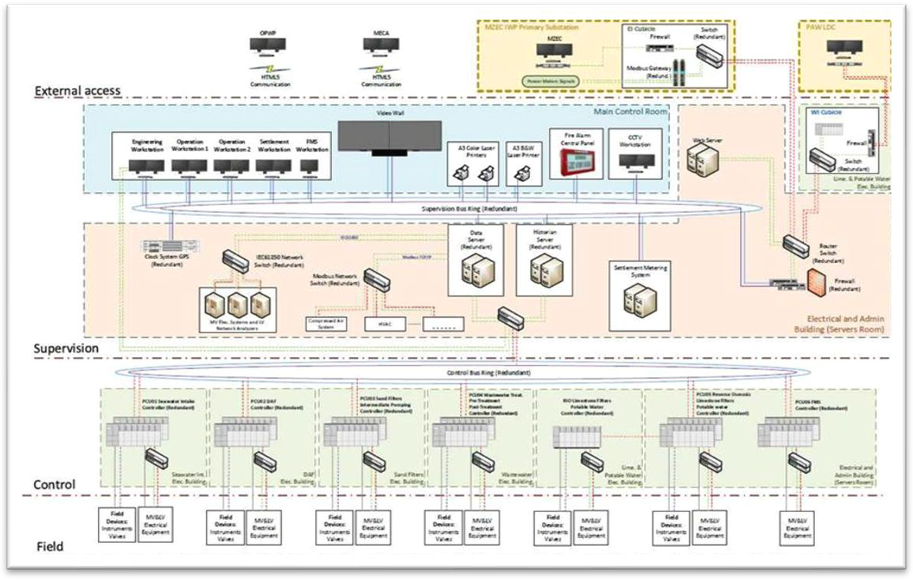

*Image24 .- Control architecture*

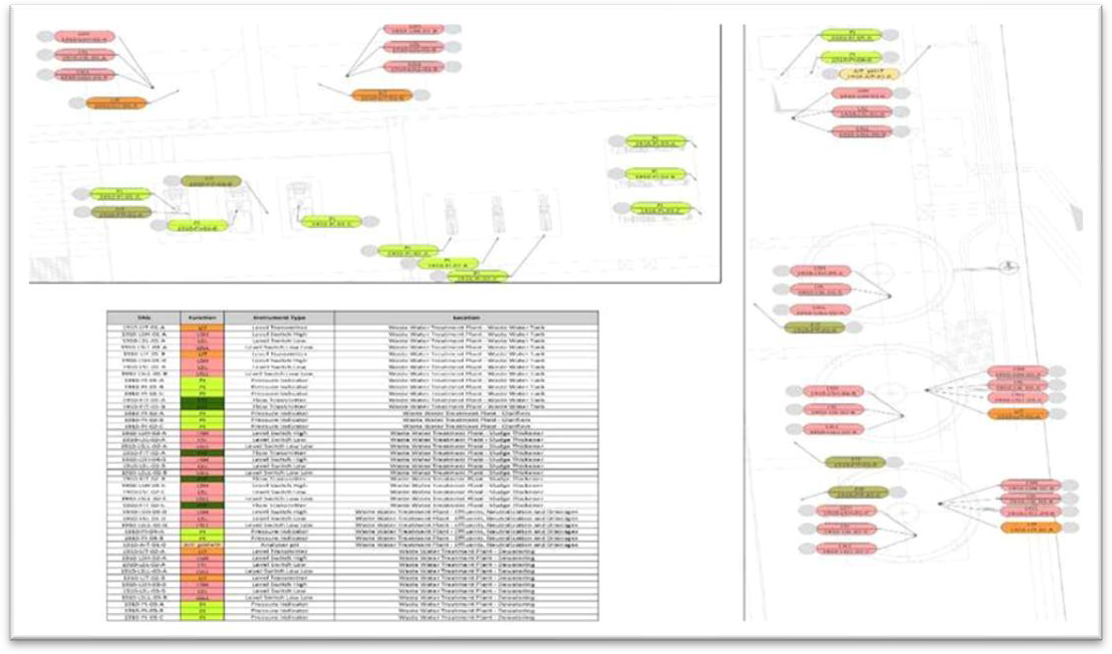

*Image25 .- Instrument layout*

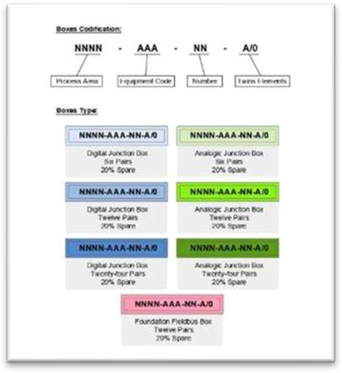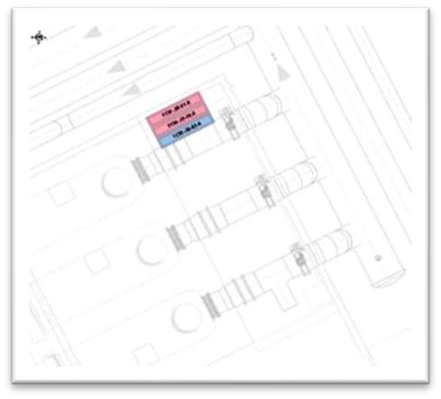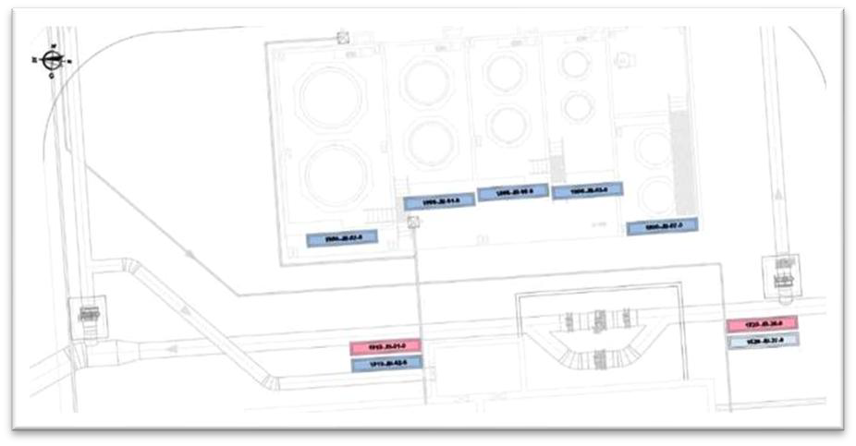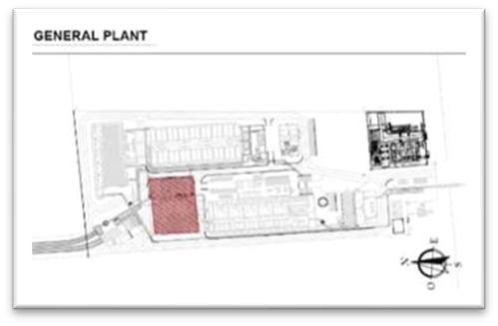

*Image26 .- Location of instrument interconnection boxes*

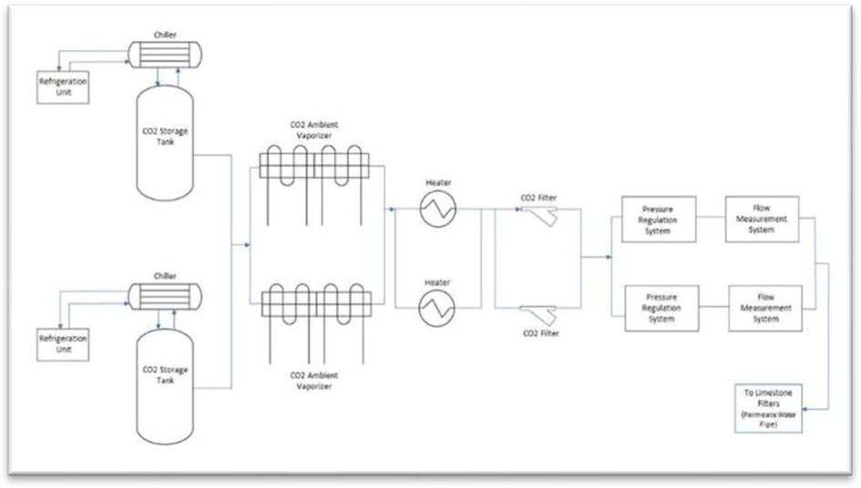

*Image27 .- Diagram of the initial process of the CO2 storage and dosing system*

## Jubail 3A Desalination Plant

MEP-Projects participated in the development of the instrumentation and control engineering, electricity and HVAC systems. In addition, we modelled the desalination plant in 3D.

The Jubail 3A desalination plant is a 600,000 m³/day plant located on the coast of the Persian Gulf, east of Saudi Arabia, in the industrial city of Jubail, about 100 km from Dammam, Saudi Arabia.

Below are some images of the detailed engineering development of this project:

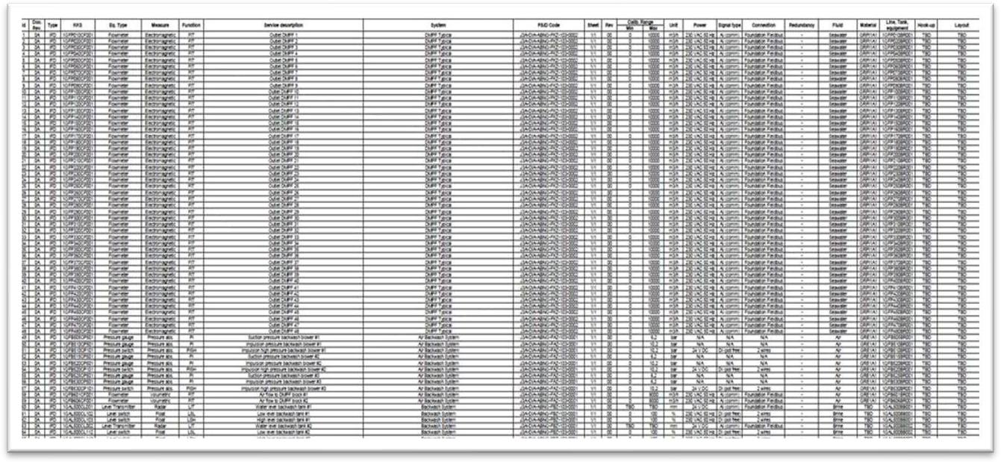

*Image28 .- Detail of the list of instruments at Jubail 3A*

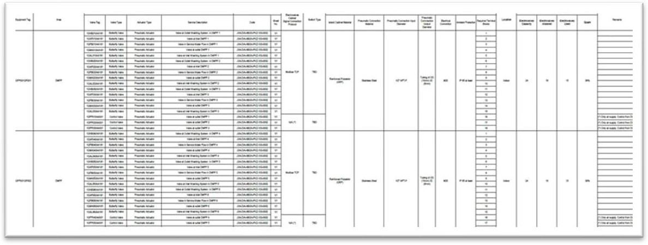

*Image29 .- Detail of the list of solenoid valve boxes*

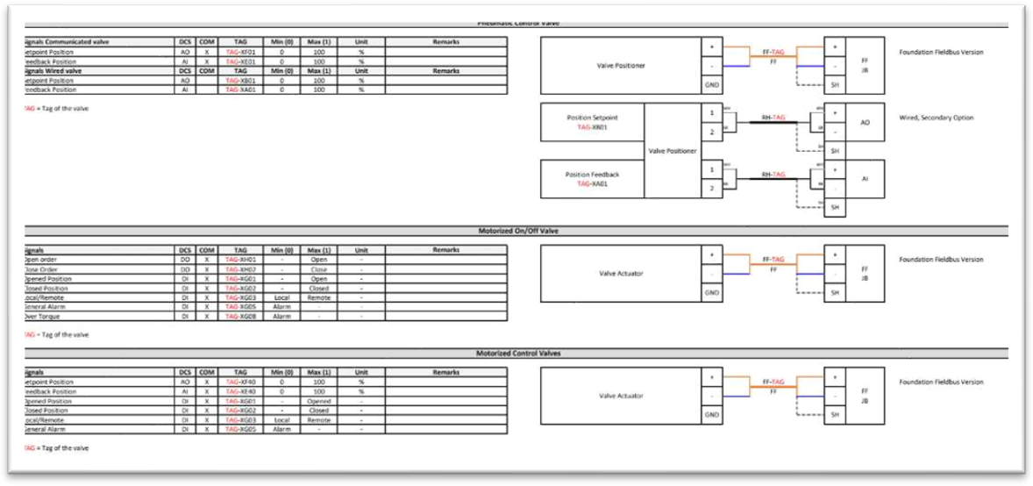

*Image30 .- Detail of typical electrical signals.*

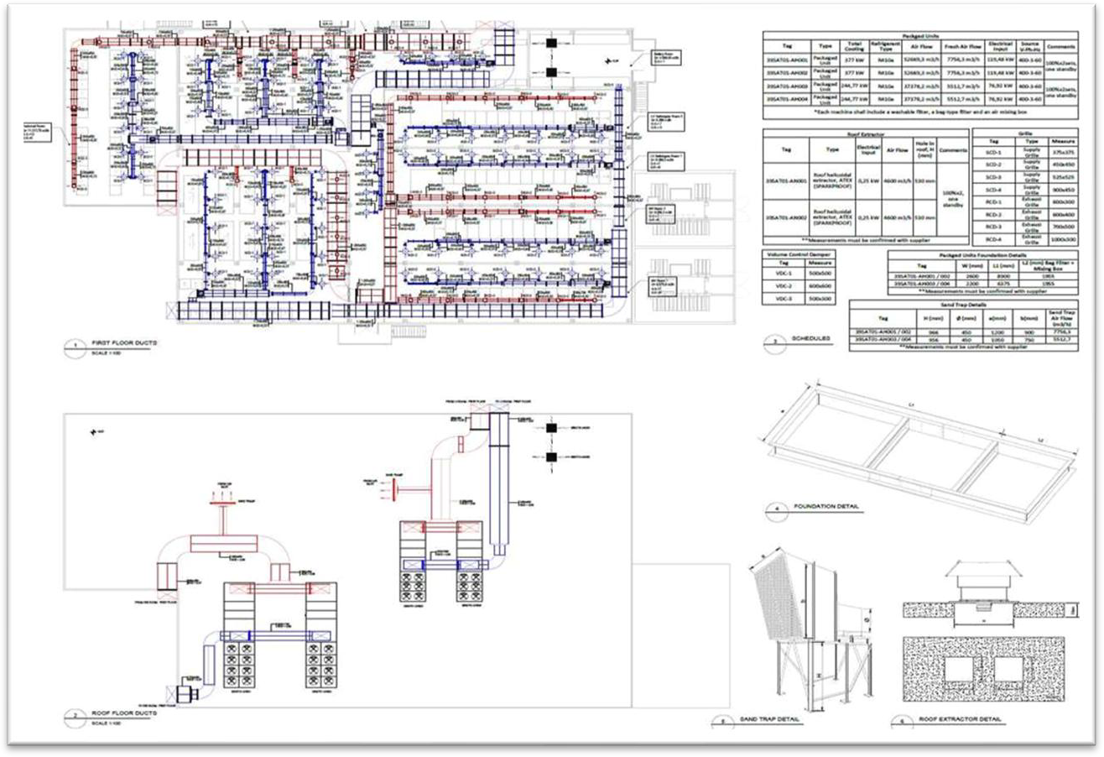

*Image31 .- Detail of the 2D plan of the installation of air conditioning ducts and HVAC equipment*

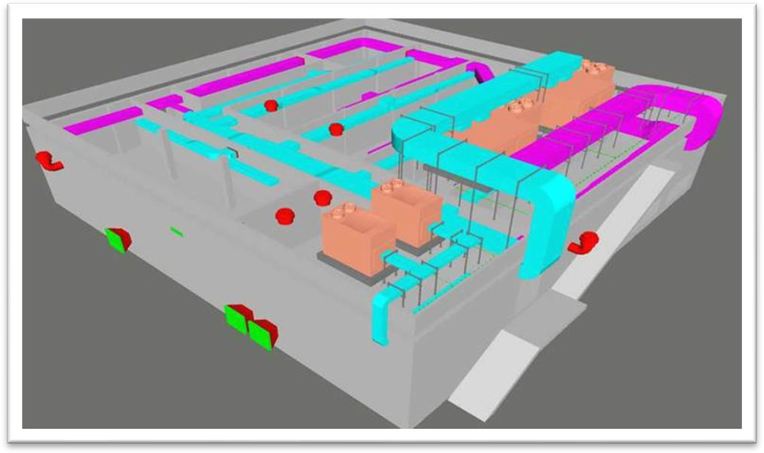

*Image32 .- 3D detail of HVAC in electrical building and equipment installation on roof*

## Agadir Desalination and Irrigation Project

This project consisted of the development of complete detailed engineering for the electrical, I&amp;C, piping and mechanical disciplines, as well as part of the 3D modelling of the desalination plant project, together with the development of the irrigation system project, with a capacity of 275,000 m³ of desalinated water per day, for combined use as drinking water 150,000 m³ /day and irrigation water 125,000 m³ /day, with the possibility of future expansion to a capacity of 400,000 m³

/day.

This desalination plant covers an area of 20 hectares and is located on the Atlantic coast, south of the city of Agadir. It is intended to meet the drinking water needs of the city of Agadir, as well as supplying irrigation water to the 150,000 agricultural plains of Chtouka.

In addition to this project, detailed engineering has been carried out for the irrigation project, including all irrigation infrastructure (storage reservoir, five pumping stations, 22 km main canal and 489 km distribution network), to transport the desalinated water to the storage reservoir for subsequent supply to the city of Agadir.

Below are images of the development of the detailed engineering for this project:

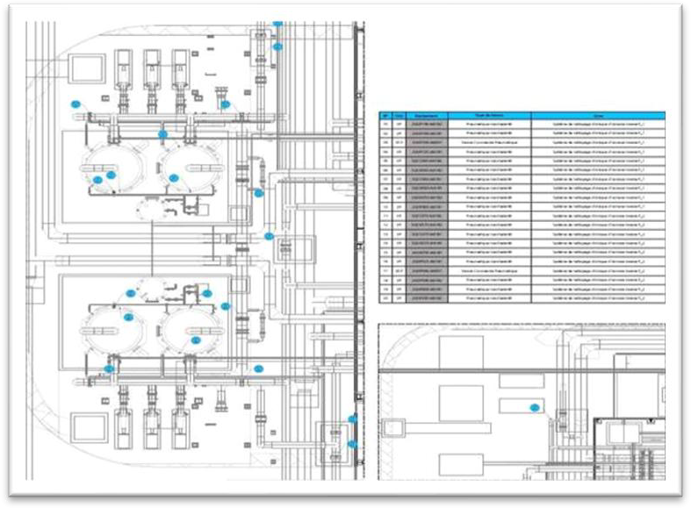

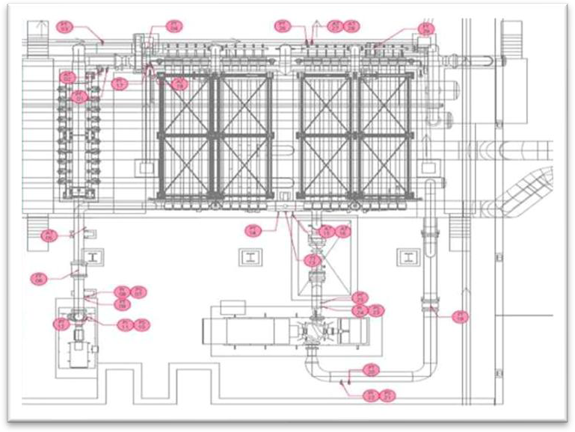

*Image33 .- Detail of the location plans for valves and instruments*

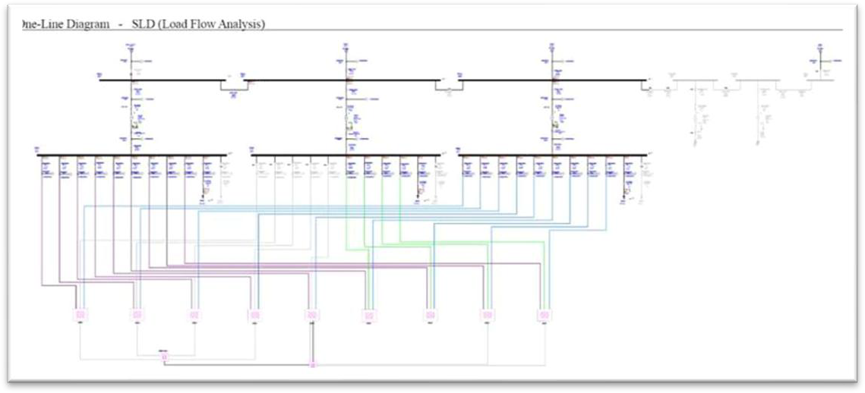

*Image34 .- Electrical studies carried out with ETAP*

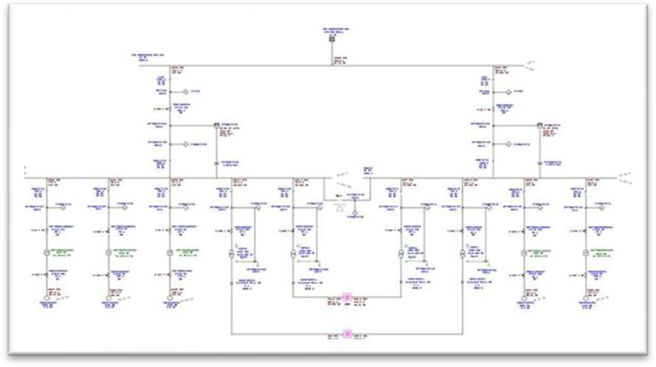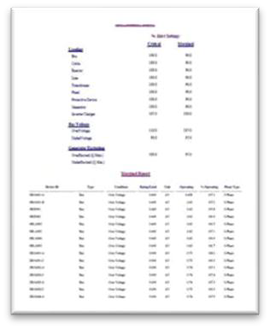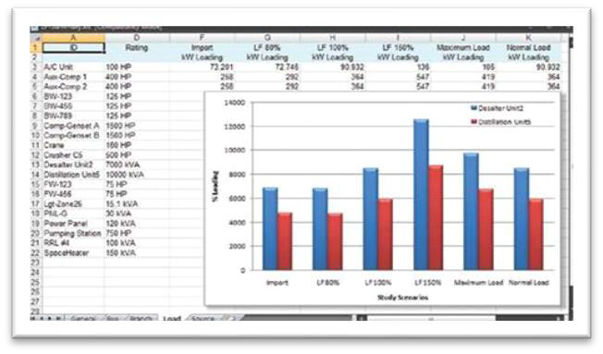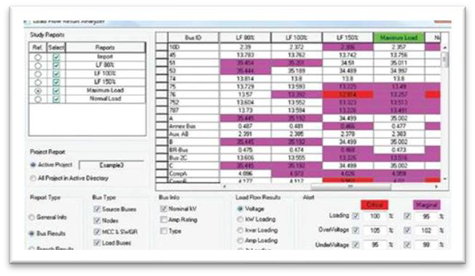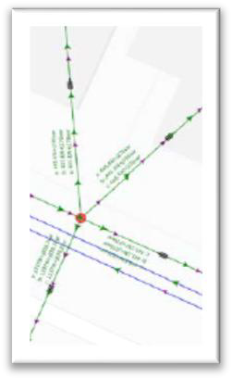

*Image35 .- Electrical load flow studies and reactive power analysis*

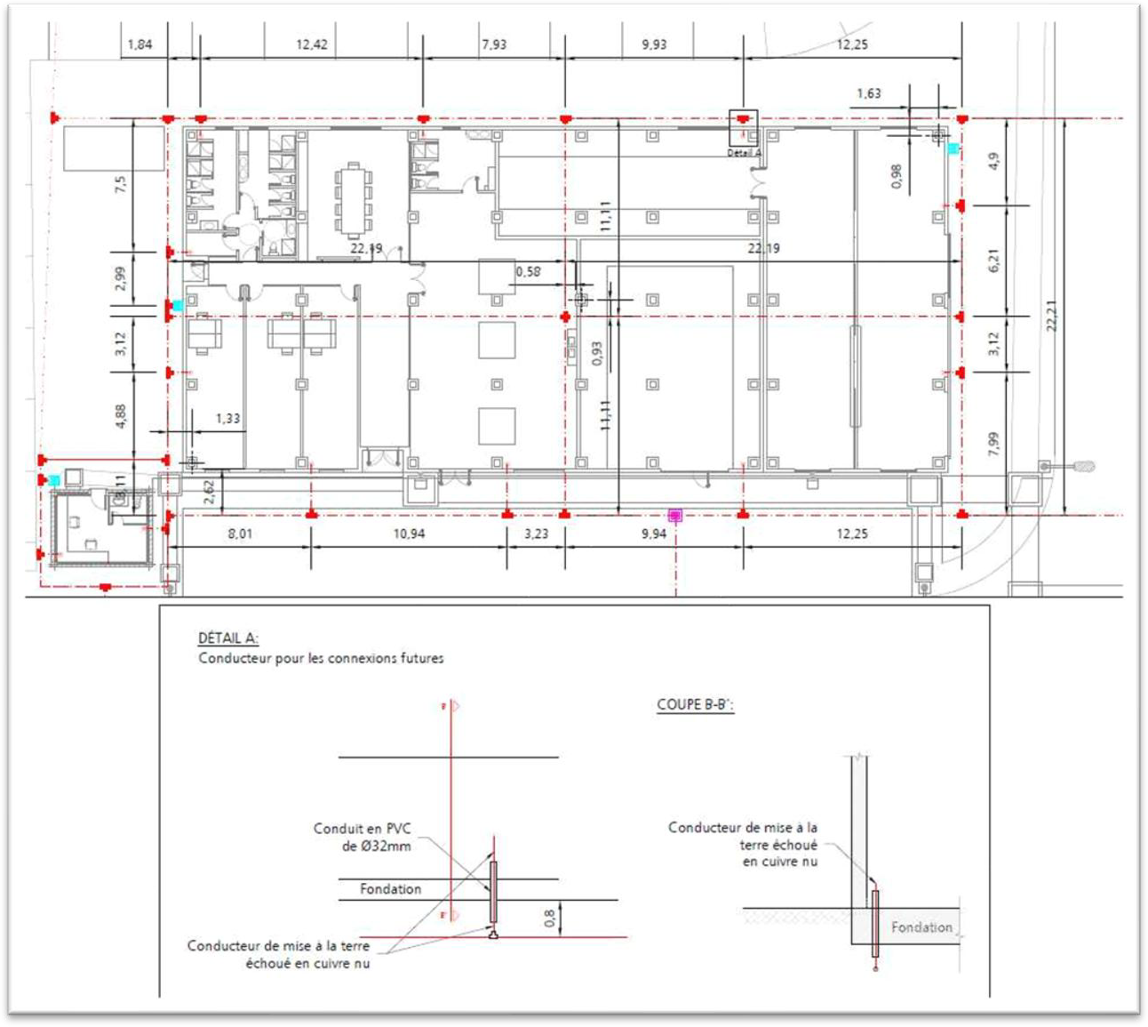

*Image36 .- Layout and details of the PaT system designed by MEP*

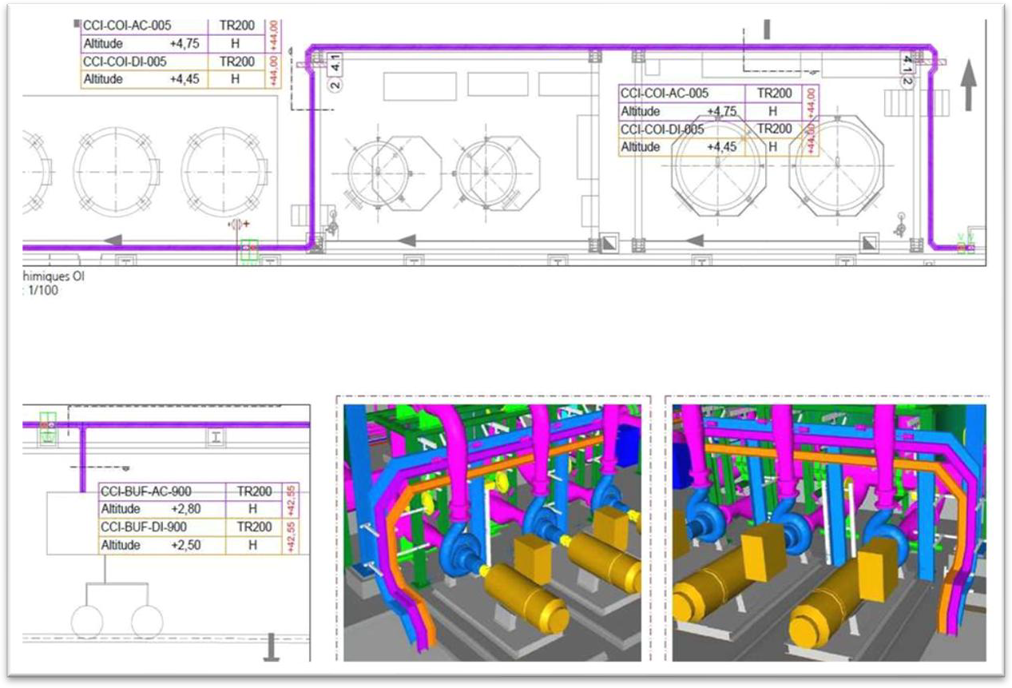

*Image37 .- Electrical and I&amp;C piping plans*

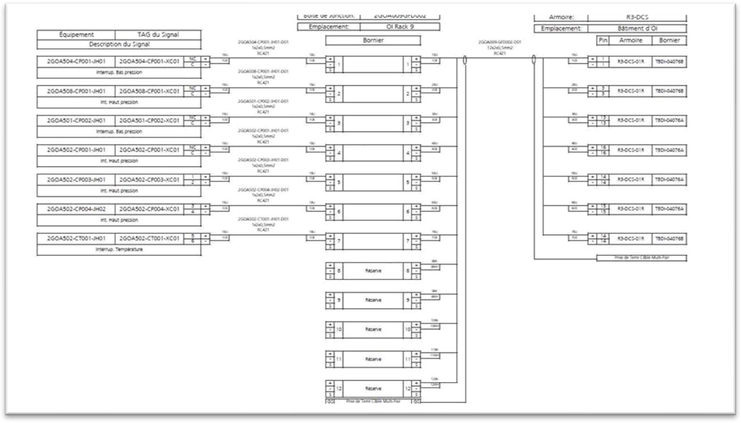

*Image38 .- Detail of the interconnection plans for the instrumentation and control cabling*

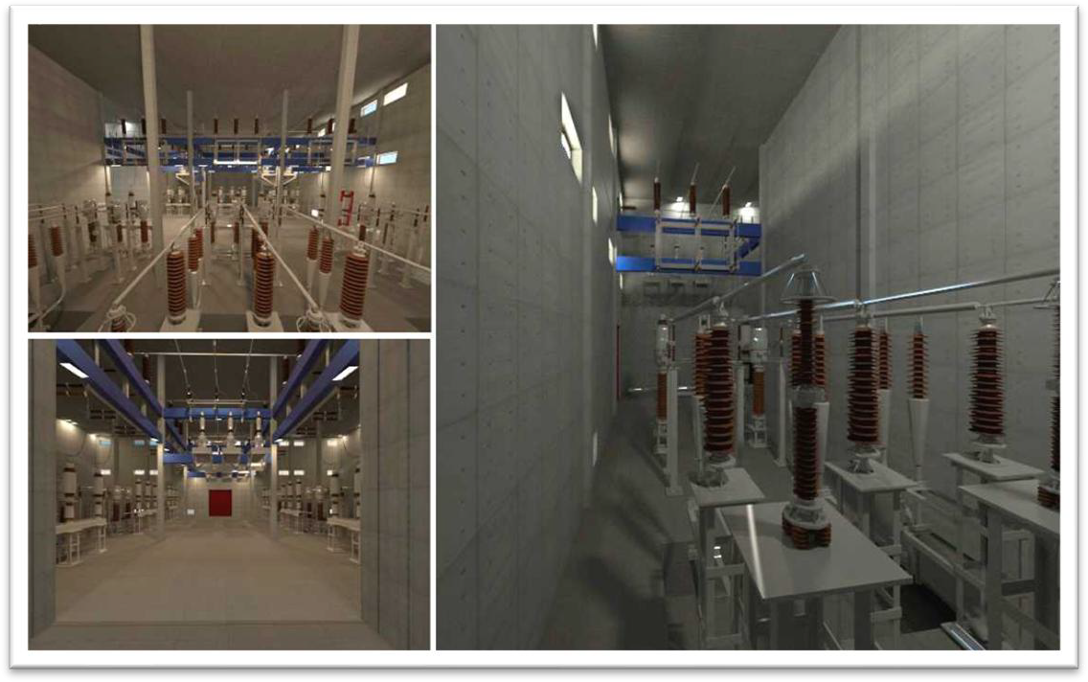

*Image39 .- Detailed engineering of the electrical substation at the desalination plant*

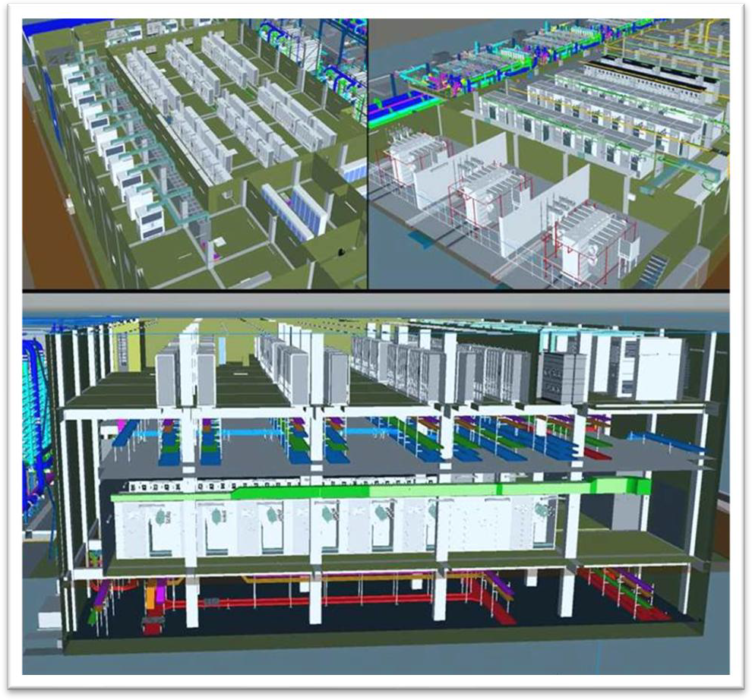

*Image40 .- General layout of the electrical building and 3D modelling*

## Dubal Desalination Plant

Dubal is a 41,000 m³/day desalination plant located in the port city of Jebel Ali, 35 km southwest of Dubai, in the United Arab Emirates. MEP-Projects carried out the basic and detailed engineering for the Instrumentation and Control, Mechanical and Piping disciplines and their 3D modelling, with integration into the client's modelling.

The plant includes pre-treatment by dissolved air flotation (DAF) and gravity filters, a five-rack reverse osmosis system, post-treatment of calcite and carbon dioxide (CO₂) beds, and pumping of the product water. It also has an ultrapure water production system using electrodeionisation treatment.

Below are images of the detailed engineering development of this project:

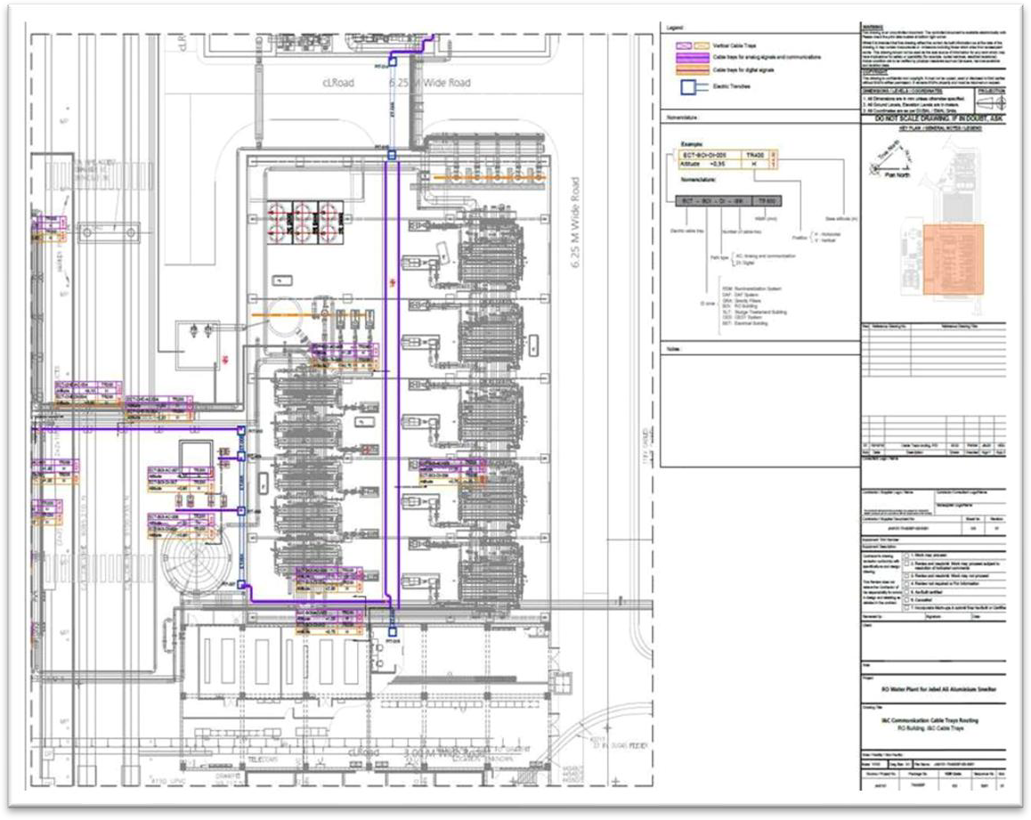

*Image41 .- Detail of the I&amp;C tray plan*

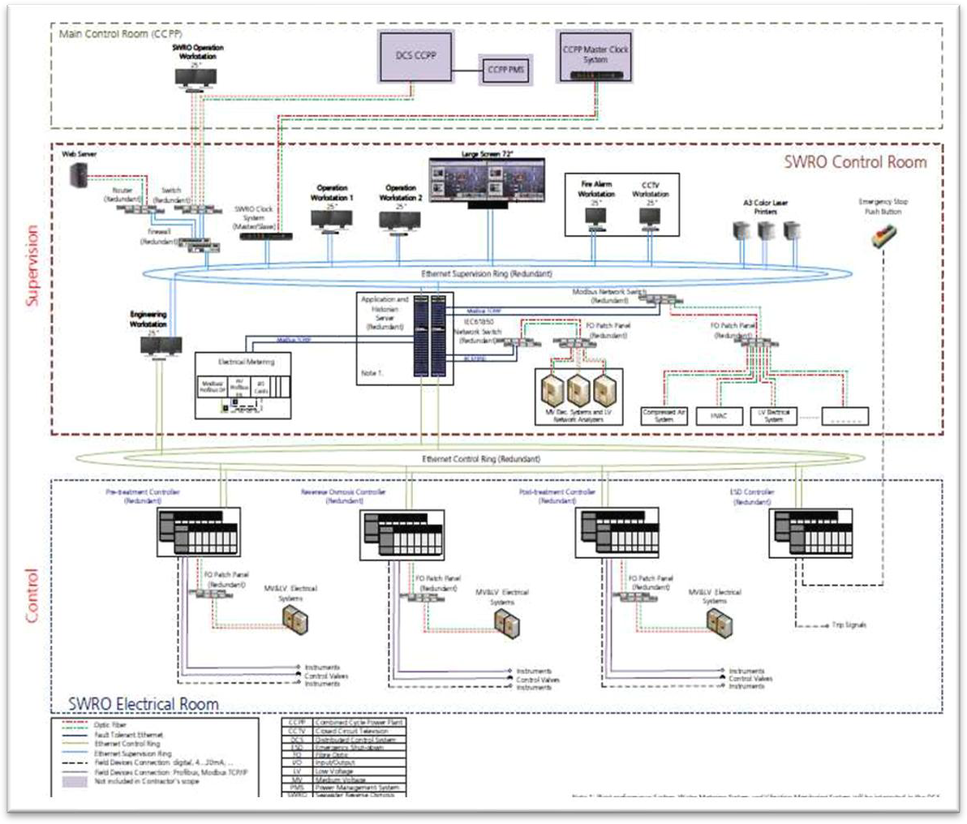

*Image42 .- Detail of the control architecture*

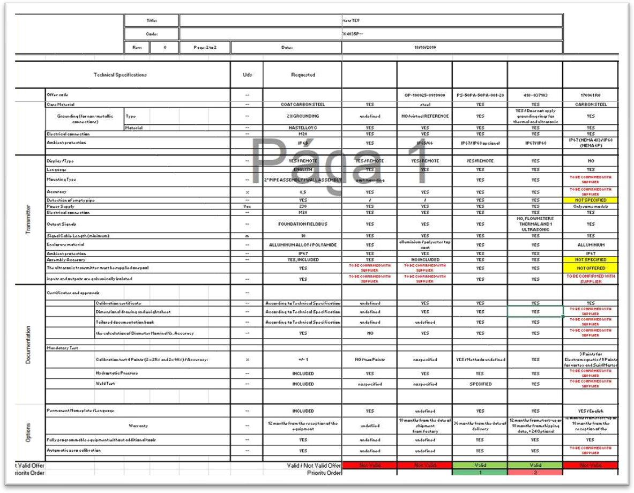

*Image43 .- Detail of the technical tabulation carried out*

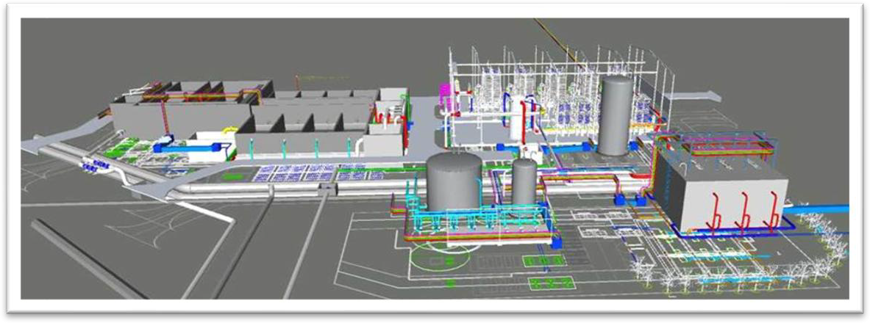

*Image44 .- 3D of the Dubal desalination plant*

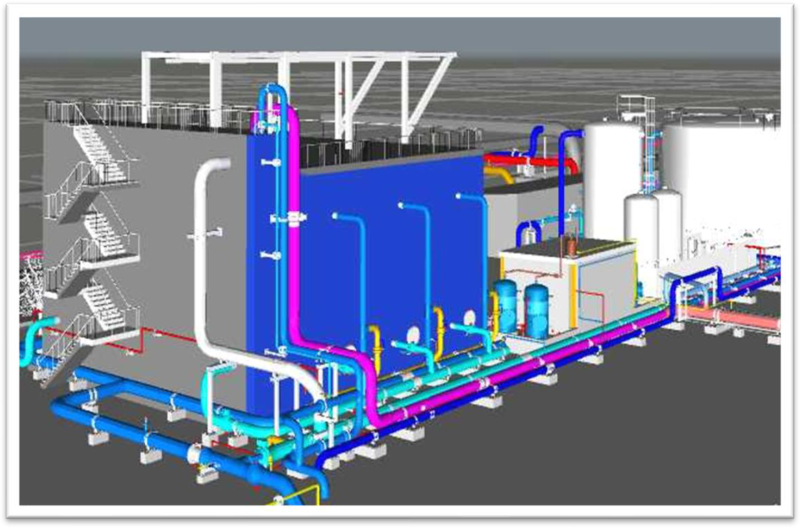

*Image45 .- Remineralisation piping systems*

## Shuaibah III Desalination Plant

MEP-Projects participated in the development of the detailed engineering for this desalination plant, with a capacity of 250,000 m³/day, using reverse osmosis technology.

The plant, located in an area about 150 km south of Jeddah, consists mainly of a seawater intake, a reverse osmosis section for the production of drinking water and a special pipeline for the return of a concentrated brine stream. The plant currently supplies the Jeddah, Makkah and Taif areas.

The scope of MEP included electrical studies and calculations, as well as the calculation, design and plans for the interior and exterior lighting fixtures.

Below are some images of the detailed engineering carried out for this project:

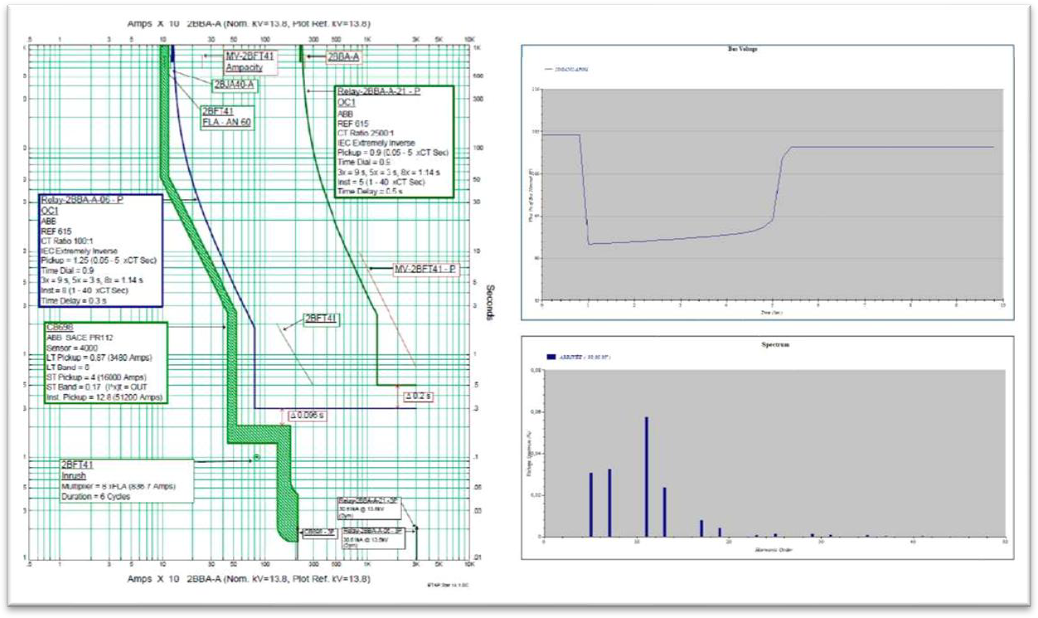

*Image46 .- Electrical studies of the plant*

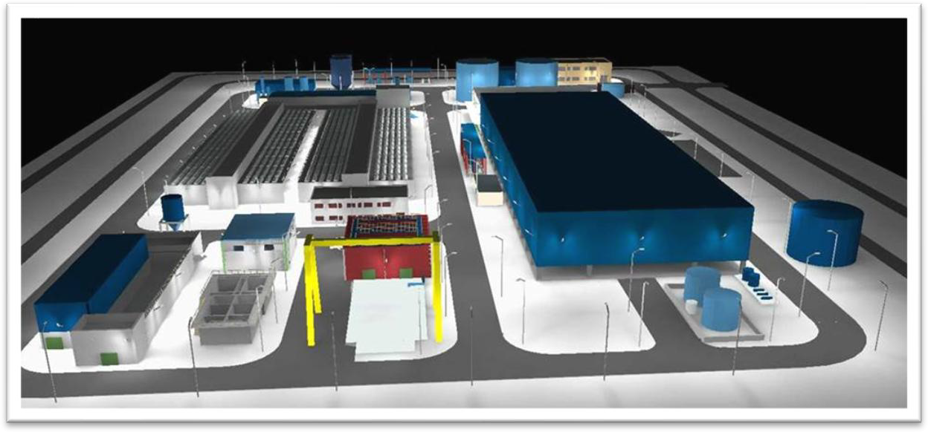

*Image47 .- Dialux modelling of an outdoor lighting system*

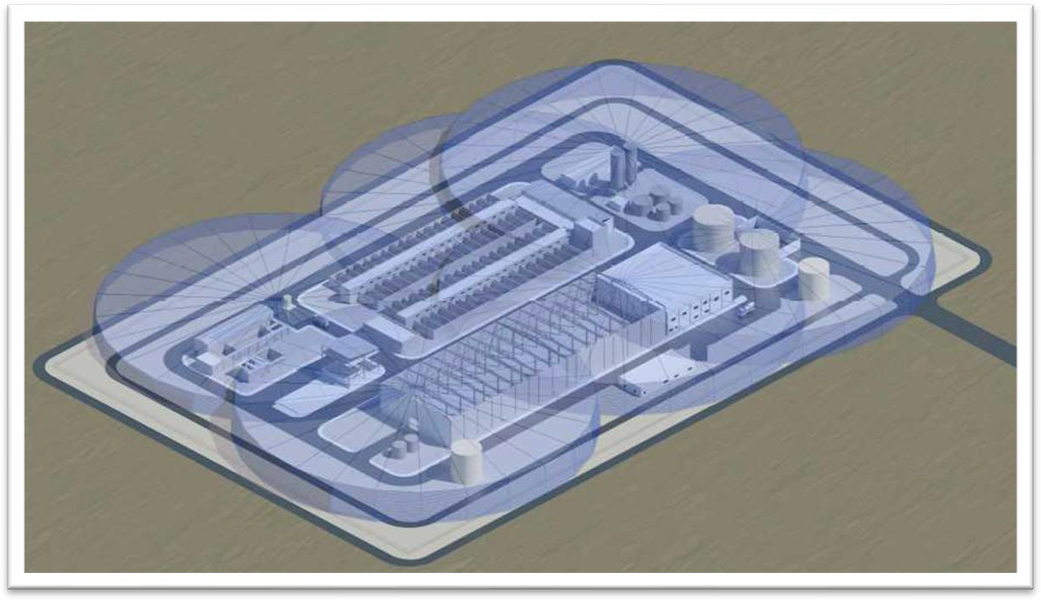

*Image48 .- Detailed study of lightning protection*

## Sewerage Network and Pumping Station in Dubai

The project involved the development of tender engineering in the disciplines of Electricity, I&amp;C, Piping, Mechanics, Civil Engineering, Hydraulics and Processes, as well as part of the 3D modelling. Its main objective is the construction of the Dubai Strategic Sewerage Tunnels (DSST), intended to replace the existing gravity-based sewerage infrastructure with a gravity-based system. This transformation aims to ensure long-term hydraulic capacity and contribute to environmental sustainability by eliminating most of the pumping stations currently in service.

The scope of engineering developed by MEP covered tunnels with a length of over 120 km, depths ranging from 30 m to 122 m, and diameters varying between 3.5 m and 6.5 m.

The wastewater transported through the collector tunnels converges at two terminal pumping stations with capacities of 5,500 MLDs and 1,600 MLDs, respectively. At these facilities, MEP also participated in the disciplines of Electrical, I&C, Piping, Mechanical, Civil, Hydraulics and Processes, in addition to executing 3D modelling and CFD modelling of both the inlet channel and the discharge chamber.

Below are images corresponding to the development of the detailed engineering of the project:

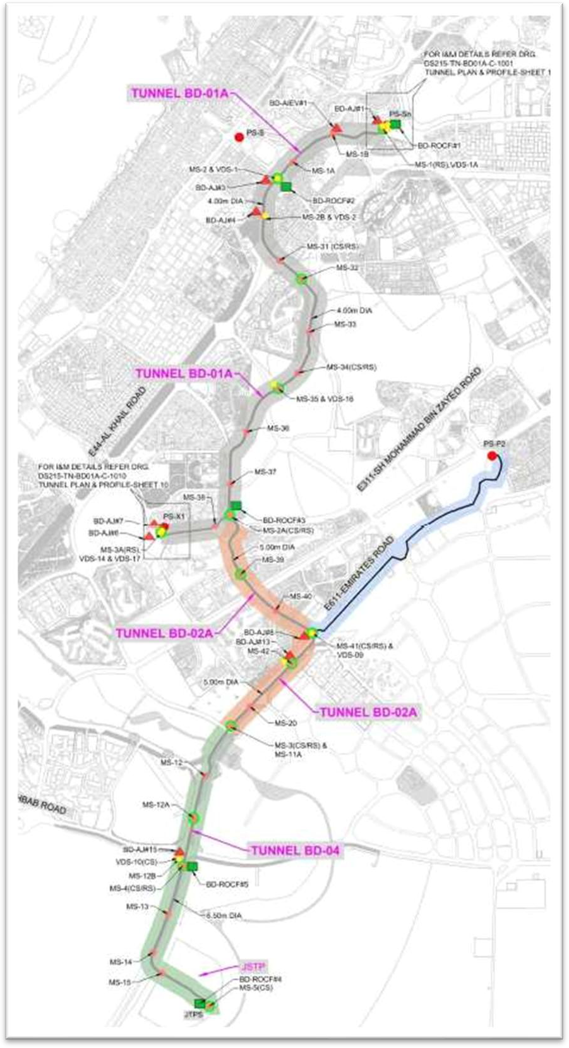

*Image49 .- General location of the project*

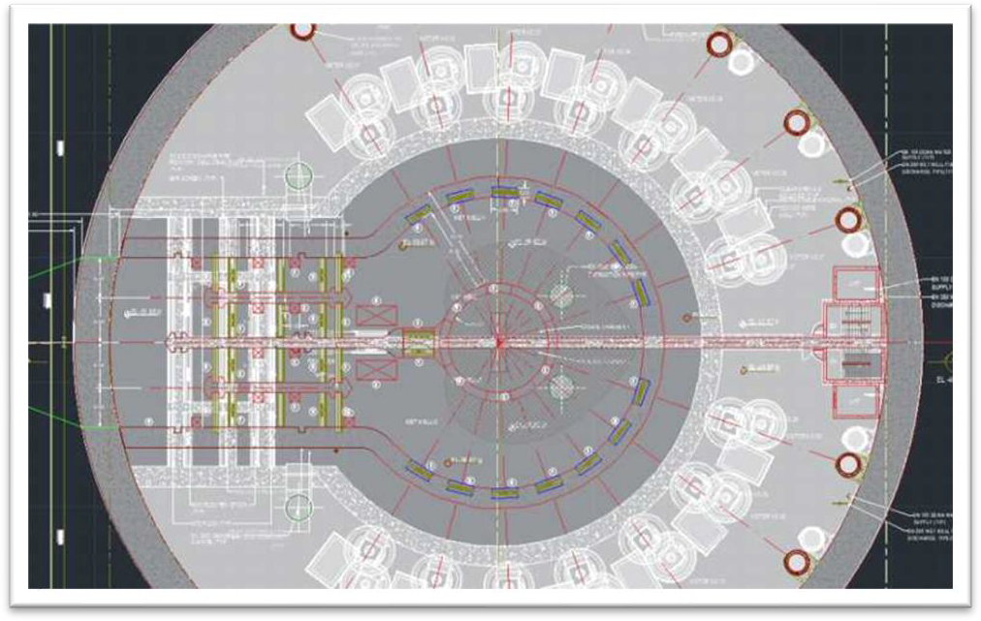

*Image50 .- Inlet channel and discharge chamber design*

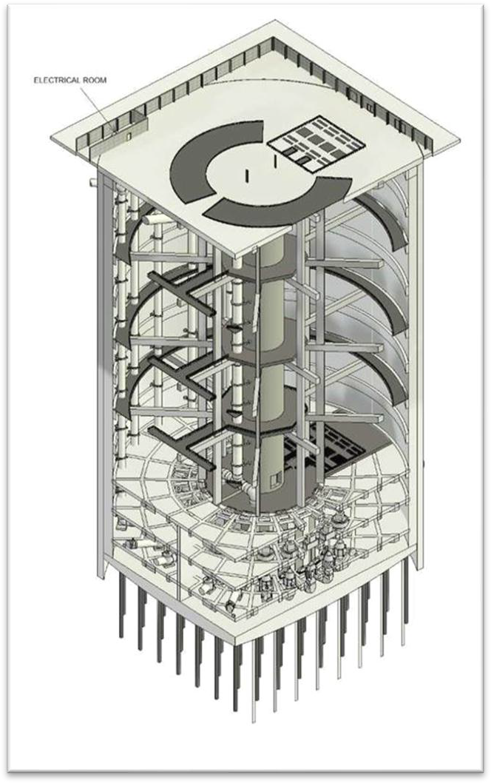

*Image51 .- JTPS 3D model*

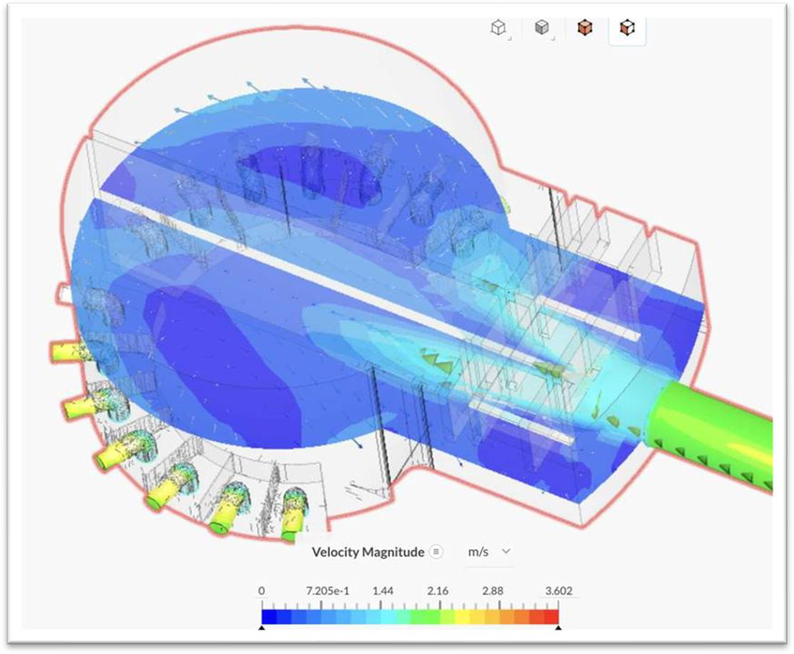

*Image52 .- Full intake velocity*

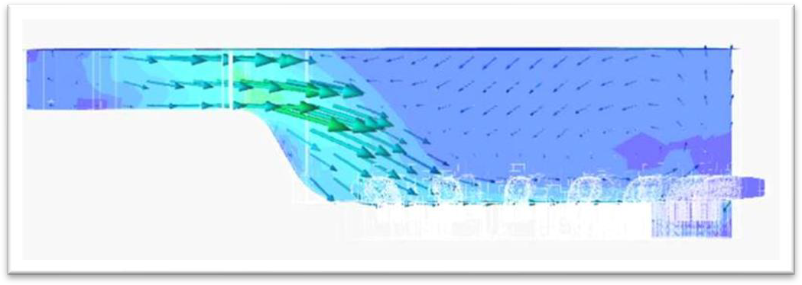

*Image53 .- Longitudinal section through the wet well*